Test Case: tc001_SPX_Dev5_Crear_Solicitud_Articulo_Almacen
Step 1 - Enter username and password and click to button Enter : Credentials Entered
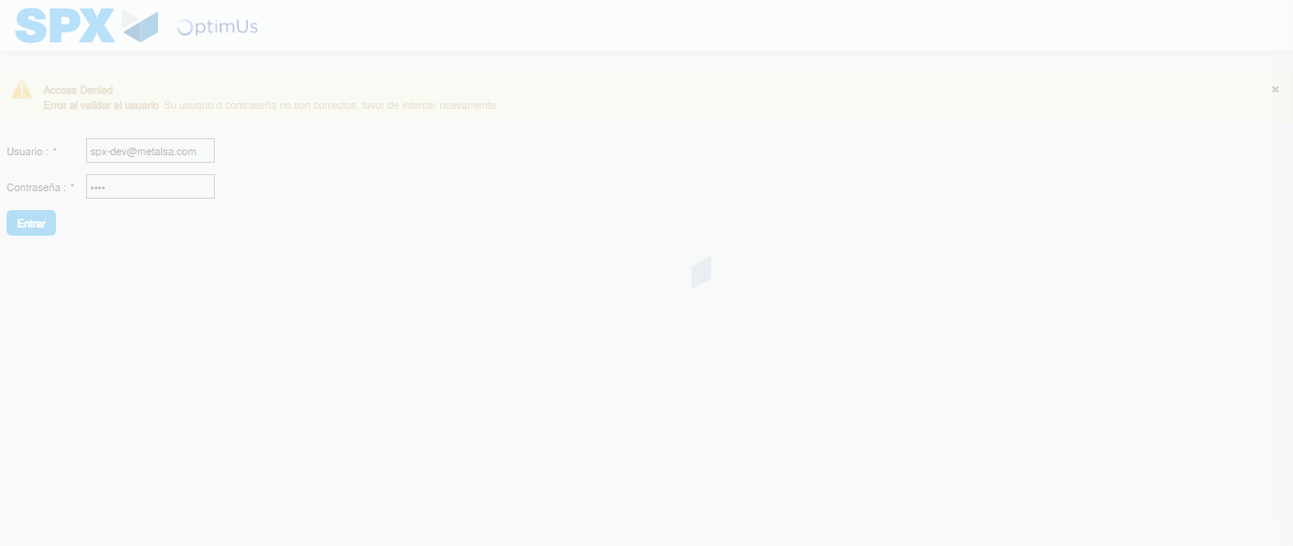Image file-name: QC_Testing-tc001_SPX_Dev5_Crear_Solicitud_Articulo_Almacen-1787938987666

Step 2 - Select to UEN and Access to Request for a New Inventory Item : UEN Correctly selected and Correct access
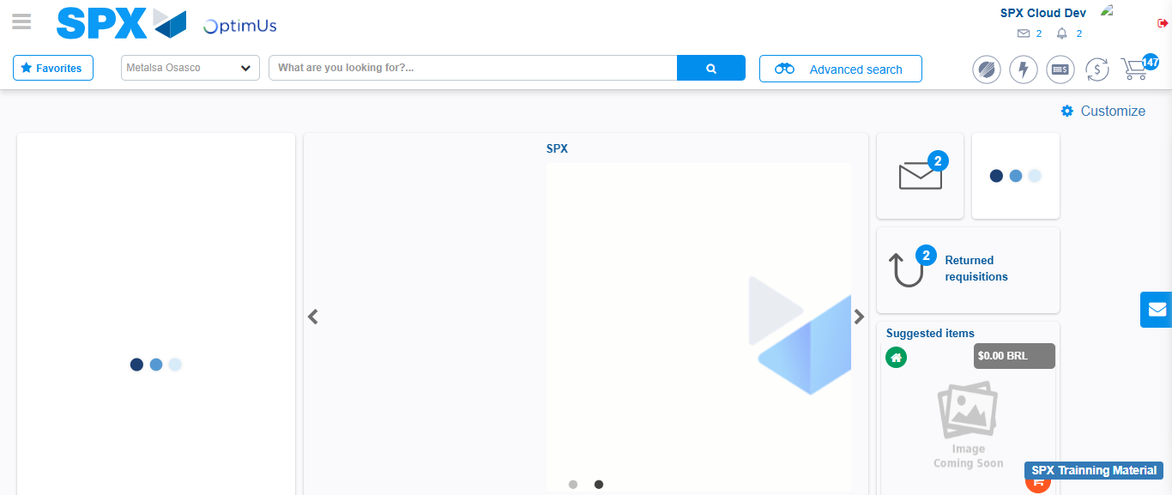Image file-name: QC_Testing-tc001_SPX_Dev5_Crear_Solicitud_Articulo_Almacen-1787939014300

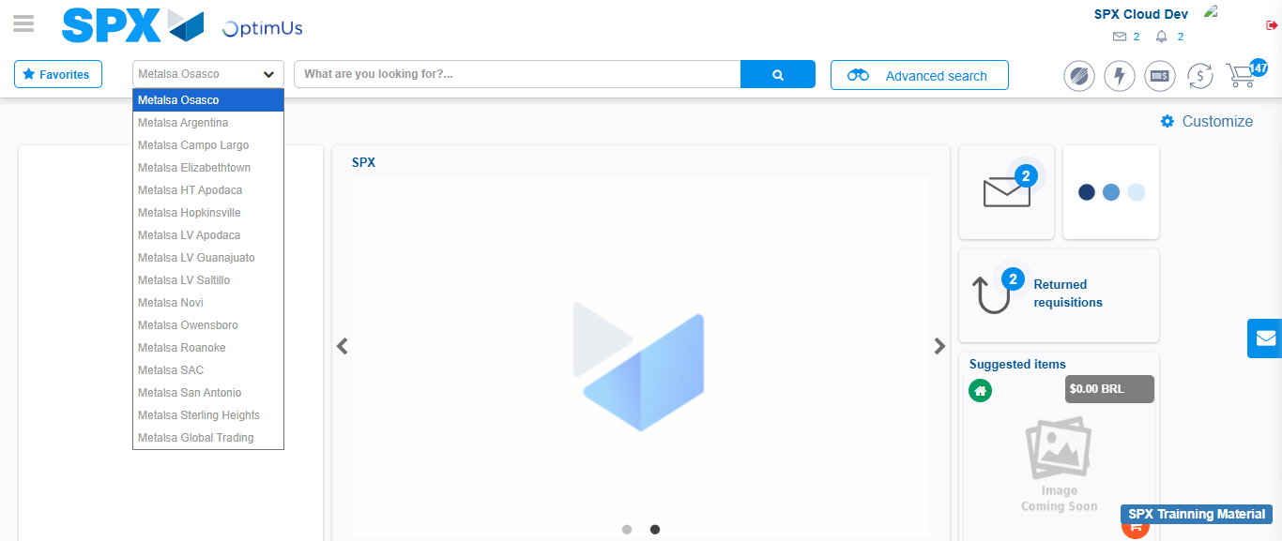Image file-name: QC_Testing-tc001_SPX_Dev5_Crear_Solicitud_Articulo_Almacen-1787939014848

Image file-name: QC_Testing-tc001_SPX_Dev5_Crear_Solicitud_Articulo_Almacen-1787939065416

Step 3 - Select options first section : Options seleted correctly
Image file-name: QC_Testing-tc001_SPX_Dev5_Crear_Solicitud_Articulo_Almacen-1787939065648

Image file-name: QC_Testing-tc001_SPX_Dev5_Crear_Solicitud_Articulo_Almacen-1787939065798

Step 4 - Select options at Screen: Options seleted correctly
Image file-name: QC_Testing-tc001_SPX_Dev5_Crear_Solicitud_Articulo_Almacen-1787939065648

Image file-name: QC_Testing-tc001_SPX_Dev5_Crear_Solicitud_Articulo_Almacen-1787939065798

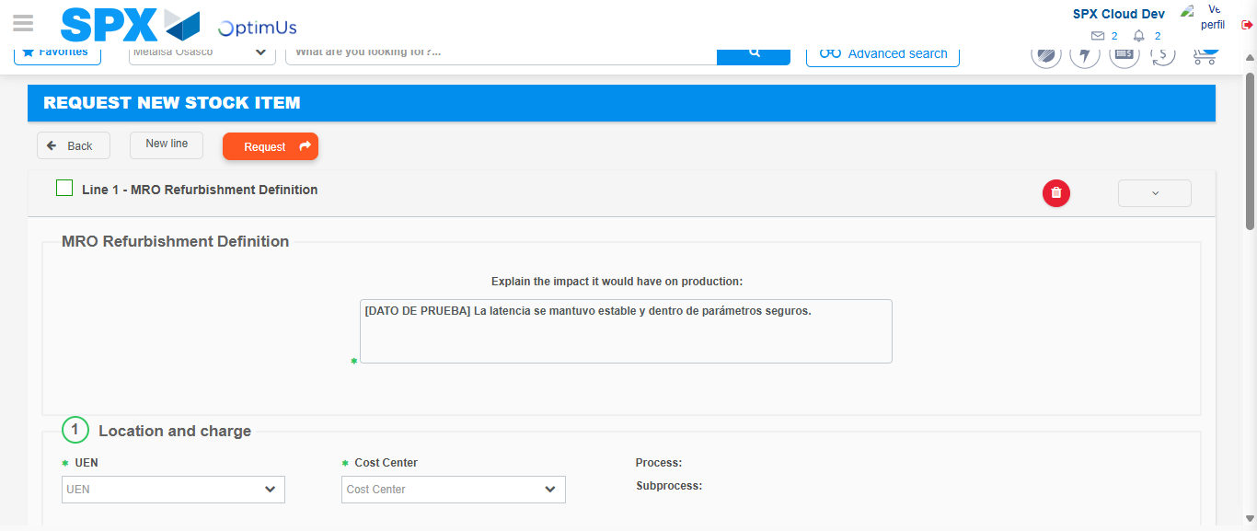Image file-name: QC_Testing-tc001_SPX_Dev5_Crear_Solicitud_Articulo_Almacen-1787939075472

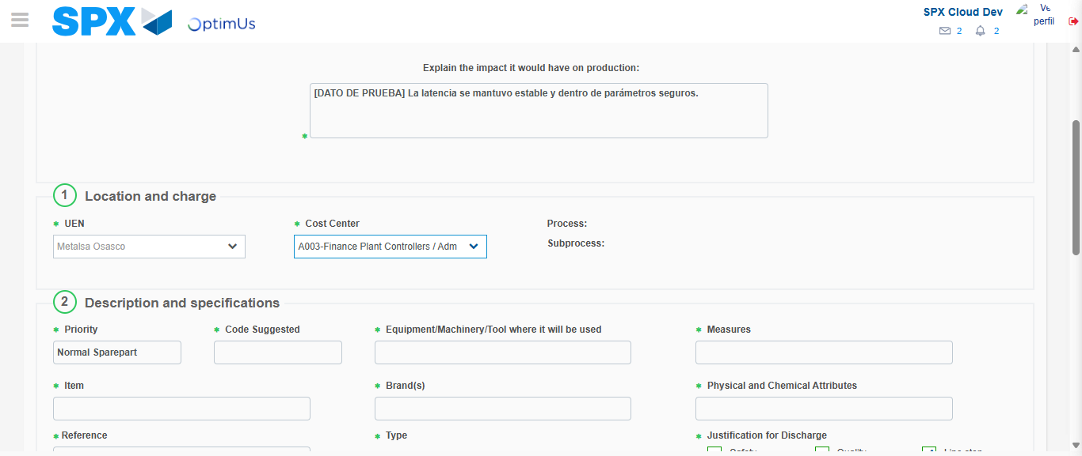Image file-name: QC_Testing-tc001_SPX_Dev5_Crear_Solicitud_Articulo_Almacen-1787939077890

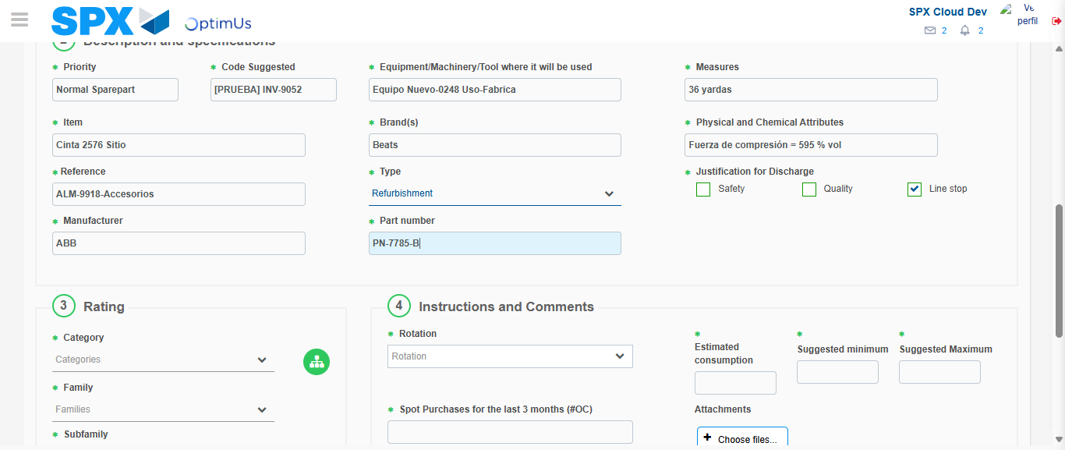Image file-name: QC_Testing-tc001_SPX_Dev5_Crear_Solicitud_Articulo_Almacen-1787939079066

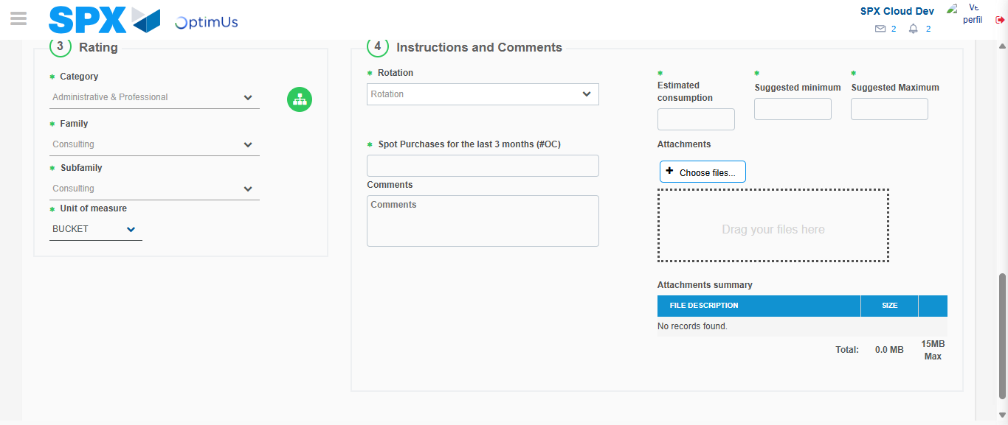Image file-name: QC_Testing-tc001_SPX_Dev5_Crear_Solicitud_Articulo_Almacen-1787939083146

Step 5 - Request New Item : Request Accepted
Image file-name: QC_Testing-tc001_SPX_Dev5_Crear_Solicitud_Articulo_Almacen-1787939014300

Image file-name: QC_Testing-tc001_SPX_Dev5_Crear_Solicitud_Articulo_Almacen-1787939014848

Image file-name: QC_Testing-tc001_SPX_Dev5_Crear_Solicitud_Articulo_Almacen-1787939065416

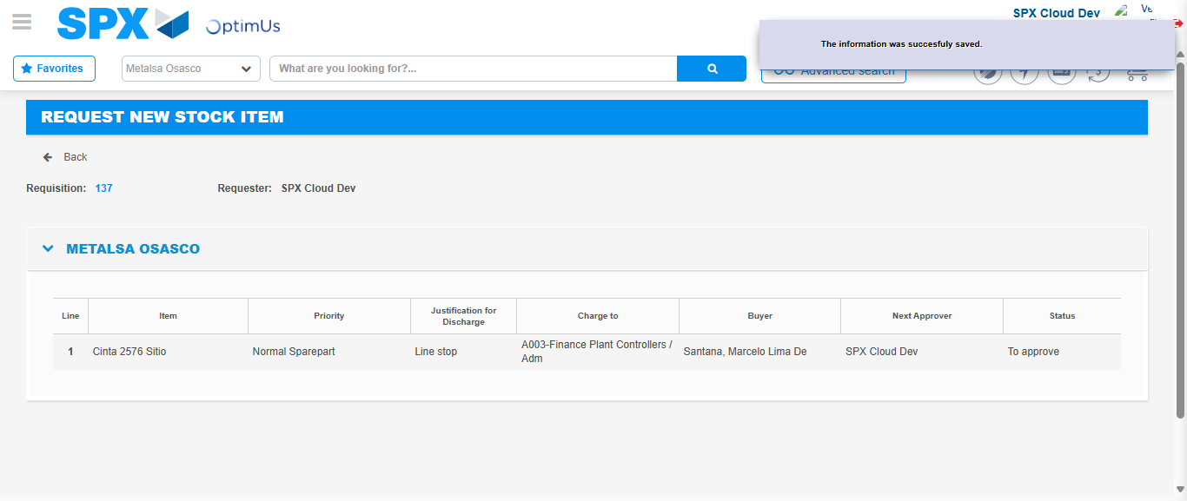Image file-name: QC_Testing-tc001_SPX_Dev5_Crear_Solicitud_Articulo_Almacen-1787939090557

Image file-name: QC_Testing-tc001_SPX_Dev5_Crear_Solicitud_Articulo_Almacen-1787939090751

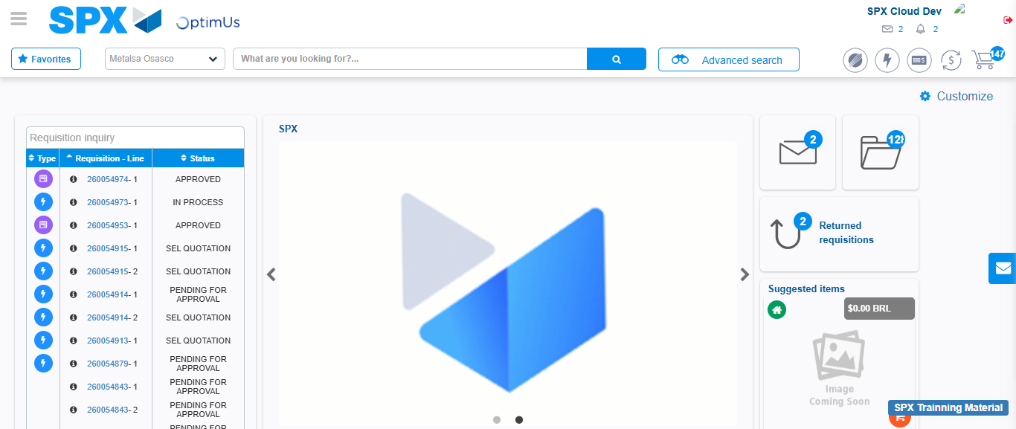Image file-name: QC_Testing-tc001_SPX_Dev5_Crear_Solicitud_Articulo_Almacen-1787939112019

Step 7 - Return to Main Page SPX : Return to Main Page SPX
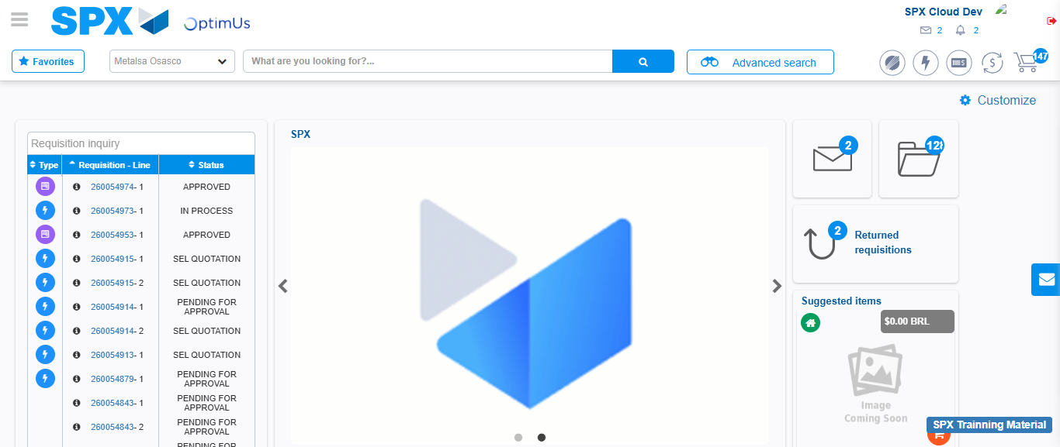Image file-name: QC_Testing-tc001_SPX_Dev5_Crear_Solicitud_Articulo_Almacen-1787939112302

